**Payroll Files – Premium Listings**

Step 1 (this will remain with the team)

1. Log JIRA ticket with IT requesting the data
2. Password Apple(month)(year)
3. Save file to location below

* Z:\BANKING 2021\BILLING 2013\GROUP SCHEME REPORTS\APPLE\Payroll Files\Raw Data Files.

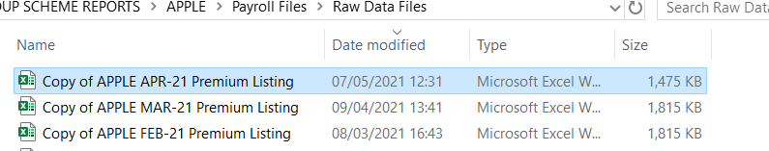

__________________________________________________________________________________

Step 2 – Creating a pivot

* Open theLIVE Tab and highlight all – Insert Pivot Table
* Include to below fields:
  + Policy No (Rows)
  + Sum of Net of GD (Values)
  + Sum of TRS (Values)
  + Sum of Amount still to pay (Values)

________________________________________________________________________

Step 3 – Data Tab

* Create a new tab: Called **‘data’ – TYPE THE BELOW HEADINGS IN ‘DATA’ TAB**
  + 
  + Copy Pivot cells into Data tab, excluding the heading and grand total columns

__________________________________________________________________________________

**Step 4 - OTHER Pivot:**

* Open theother Tab and highlight all – Insert Pivot Table
* Include to below fields:
  + Policy No (Rows)
  + Sum of Net of GD (Values)
  + Sum of TRS (Values)
  + Sum of Amount still to pay (Values)
* Copy the data pulled from the **OTHER** Pivot cells and paste into the end of the Data tab –

**LIVE & OTHER tabs are combined into ‘data’ tab.** __________________________________________________________________________________

**Step 5 - VLOOKUP against Last Month’s file (Column F):**

We are now comparing the raw data file to the Current payroll file.

* **File location:** ADMIN DRIVE\BANKING 2021\BILLING 2013\GROUP SCHEME

REPORTS\APPLE\Payroll Files\Payroll Files 2021. Select: **‘previous months Payroll File’**

**Password to open is: AppleIrl2021%**

* Back to the working file: In the ‘data’ tab heading **‘Last Month’** use the below formula**:**

**FORMULA** =VLOOKUP(A231,'[April Payroll File Final 2021.xlsx]Sheet1'!$1:$1048576,7,FALSE)

**Example:**

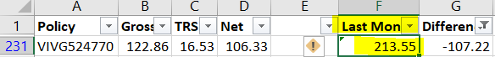

We now have **Net Premium for Current Month** + **Net Premium for Last Month**

__________________________________________________________________________________

**Step 6 - DIFFERENCE (Column G):** Compare the DIFFERENCE for month on month of net premium

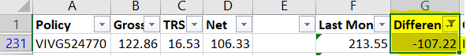

**FORMULA:** =SUM(D231-F231)

Comments will remain with the team